Contributor: Camila Maroja

**do Amaral, Tarsila**

Born: 1886—Capivari, Brazil; Died: 1973—São Paulo, Brazil

A vital figure in Brazilian Modernism, the painter Tarsila do Amaral is best known for her mid-to late 1920s artworks produced between São Paulo and Paris. During this period she worked closely associated with her then husband, the writer Oswald de Andrade and created artworks that either evoked or inspired his production. Beginning late her artistic training in Brazil under traditional artists like Pedro Alexandrino (1917), Tarsila (as she is known in Brazil) travelled in 1920 to study in Paris at the famous Academie Julian and with Émile Renard. Back to São Paulo, Tarsila met the agitators of the groundbreaking event ***Modern Art Week of 1922* (*Semana de Arte Moderna de 1922*)**, which had happened earlier that year, and started the vanguardist and informal ***Group of the Five* (*Grupo dos Cinco*)** with painter Anita Malfatti and writers Mário de Andrade, Menotti del Picchia and Oswald de Andrade. After familiarizing herself with the modernist project in Brazil, Tarsila decided to go back to the French capital to receive further modernist instruction. Aiming at constructing a modern image for her native country, the painter mixed local vernacular with avant-garde form, which she learned from Cubist painters like **Fernand Léger**.

Living in Paris, Tarsila and Oswald de Andrade had an intense exchange with the Parisian avant-garde, especially with the poet **Blaise Cendrars** who joined the couple in their 1924 trip to Brazil. Stimulated by their visit to colonial cities in the interior of the country, Tarsila focused her production on native and rural motifs painted with naïf colours. This period became known as her **“Brazilwood phase”** (**“*fase Pau-Brasil*”**, 1924-1928), a term coming from the title of Oswald de Andrade’s first manifesto (**“Manifesto de Poesia Pau-Brasil”**, 1924) and poetry book (**“Livro de Poesia Pau-Brasil”**, 1925). Notable from this decade are the paintings *A Negra* (1923), which, with its geometric background, marks the beginning of the painter’s modern oeuvre, and *Abaporú* (1928), which, literally meaning “man-eater” in local Tupy indigenous idiom, which gained notoriety for spurring the anthropophagous movement and inspiring Oswald de Andrade’s **“Anthropophagous Manifesto”** (**“*Manifesto Antropófago*”**, 1928). The works realized in 1928 and 1929 constitute her anthropophagic period.

Tarsila’s style changed significantly in the 1930s. Conversely, these years also brought important changes in her private life: she and Oswald de Andrade divorced, and, due to repercussions of the 1929 crash in Brazil, she lost her fortune derived from coffee plantations. She abandoned her previous experimental concerns as well as her interest in **Cubism** and **Surrealism**, concentrating instead on social themes. This stylistic change is a reflection of her interest in socialism that spurred her 1931 visit to Moscow, where she exhibited. The artwork *Workers* (*Operários*, 1933) is the most celebrated piece from this new social production. From 1936 until the 1956 she contributed regularly to the newspaper *Diário de São Paulo*, writing about art and artists in addition to relating her experience with the European avant-garde. Although the painter cast the definitive image of Brazilian modernism, Tarsila would not be broadly recognized until 1960s, together with the establishment of the Brazilian art market. From the 1980s on, her work were included in the main Brazilian and Latin American surveys, in particular *Art of the Fantastic – Latin America 1920-1987* (Indianapolis Museum of Art, 1987), *Latin American Artists of the Twentieth Century* (MoMA, 1993), and *Tarsila Frida Amélia – Tarsila do Amaral, Frida Khalo, Amélia Peláez* (Fundación “La Caixa”, Madrid, Barcelona, 1997).

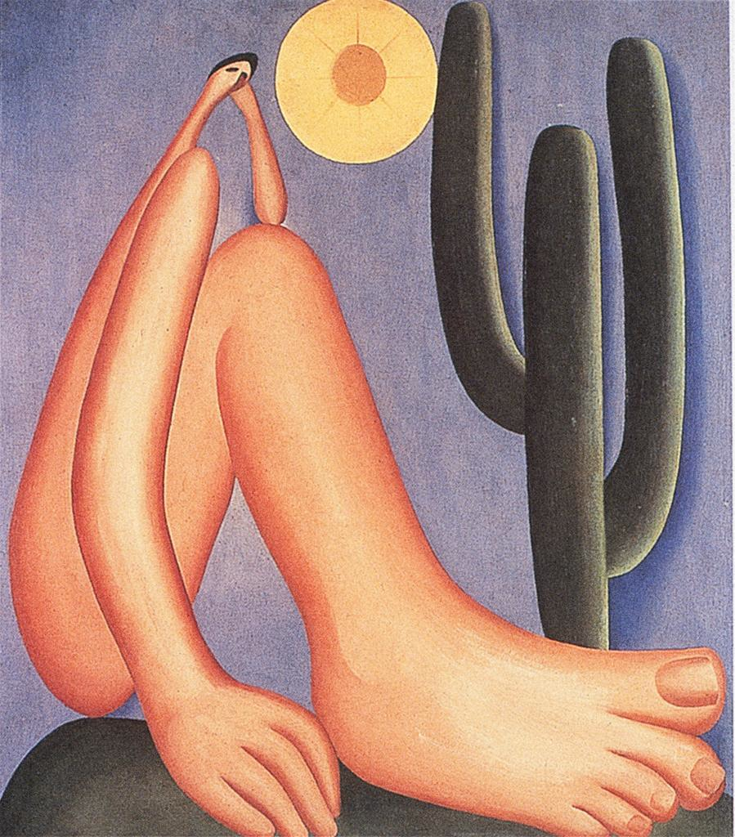

Abaporú, 1928. Details available on: http://library.artstor.org.proxy.lib.duke.edu/library/welcome.html#3|search|6|All20Collections3A20Tarsila20do20Amaral|Filtered20Search|||type3D3626kw3DTarsila20do20Amaral26geoIds3D26clsIds3D26collTypes3D26id3Dall26bDate3D26eDate3D26dExact3D26prGeoId3D||16|

**References and further reading:**

Amaral, Aracy (2003). *Tarsila: Sua Obra e Seu Tempo*. São Paulo: Edusp: Editora 34

Amaral, Tarsila do (1998). *Tarsila do Amaral* (Exh. Cat.) São Paulo: Finambrás (Projeto Cultural Artistas do Mercosul)

Bercht, Fatima (1993) “Tarsila do Amaral” in Waldo Rasmussen, Fatima Bercht and Elizabeth Ferrer (eds.), *Latin American Artists of the Twentieth Century,* (Exh. Cat.) New York: Museum of Modern Art, p. 52-59

Salzstein, Sonia (1998) “Tarsila’s Audacity” in *XXIV Bienal de São Paulo, Anthropophagy and Histories of Cannibalism* (Exh. Cat.) São Paulo: Fundação Bienal de São Paulo, p. 356-371. Availlable online at: http://issuu.com/bienal/docs/name208154

**List of Works:**

*Red Coat, Self-Portrait* (*Manteau Rouge*)*,*1923. Repository: Museu Nacional de Belas Artes (MNBA), Rio de Janeiro, Brazil.

*A Negra*, 1923. Repository: Museu de Arte Contemporânea da Universidade de São Paulo (MAC/USP), São Paulo, Brazil.

*Morro da Favela*, 1924. Collection Sérgio Fadel, Rio de Janeiro, Brazil.

*Abaporu*, 1928. Collection Eduardo Francisco Constantini, Buenos Aires, Argentina.

*The Egg (Urutu)* (*O Ovo [Urutu]*), 1928. Collection Gilberto Chateaubriand / MAM/RJ, Rio de Janeiro, Brazil.

*Workers* (*Operários*), 1933. Repository: Acervo Artístico-Cultural do Palácios do Governo do Estado de São Paulo, São Paulo, Brazil.